2.1 Metro Station Critique
The images below show different maps of the Mockingbird Station light rail station in Dallas, Texas.
Edit Figure 1 and color code it to show the following:
Single Family Houses Multi-Family Houses Apartments /Dormitories Commercial Buildings Parking Lots Green Space
Major Roads University Buildings etc.
Hints – the goal is to generalize the nearby urban form so you can critique the rail station’s location.
See the City of Dallas zoning definitions and map and zoom in a bit to see the zoning boundaries
The area west of Central Expy/US 75 highway is a mixture of university campus and residential neighborhoods. See an SMU campus map.
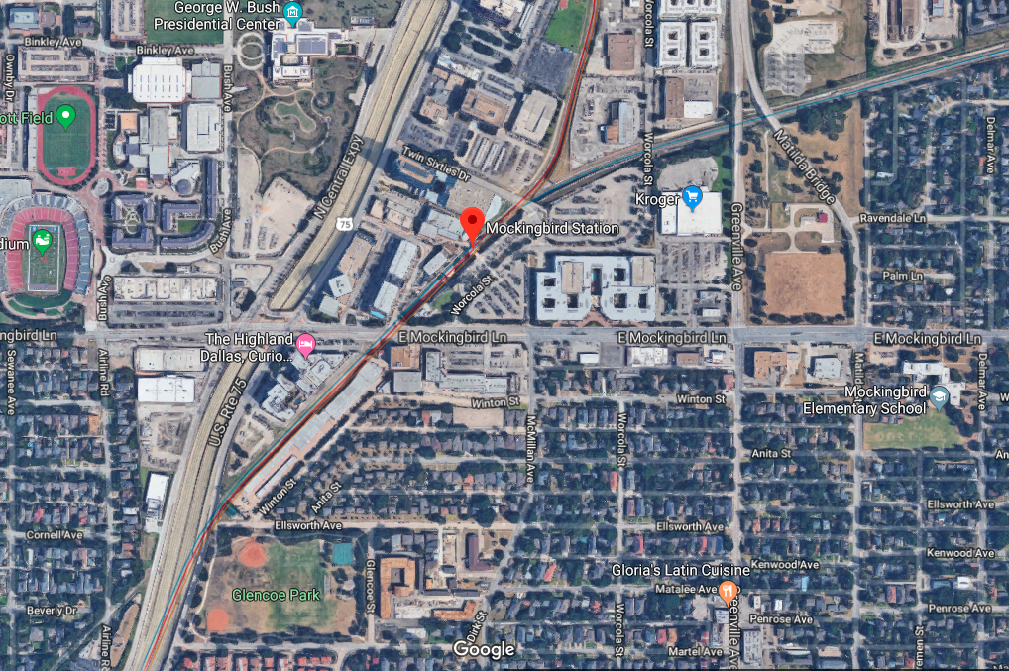
Figure 1: Google maps image of Mockingbird Station with a half-mile radius circle (denoting walkable distance from the station).
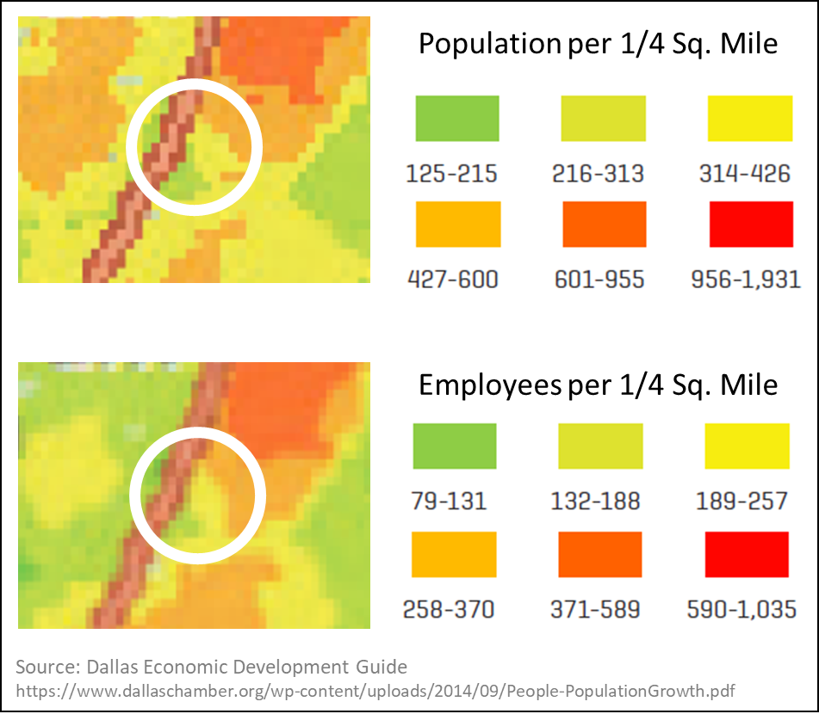
Figure 2: Half-mile radius circle around Mockingbird station over population and job density maps.
Based on Figure 2 your color coded Figure 1 and, answer the following questions:
- How does the population density around Mockingbird Station compare with the threshold values in the literature (i.e. the minimum persons/km2 suggested for mass transit success)?
- How “mixed” is the development around Mockingbird Station (“mixed” means a combination of different housing types, shopping, grocery, amenities, office space, etc.)?
How do you think the zoning mix impacts Mockingbird Station as a destination (i.e. is it a desirable location to travel for work, eating, entertainment, etc.)?
How do you think the zoning mix impacts Mockingbird Station as an origin (i.e. could you live nearby and walk to Mockingbird Station instead of driving)?
- Pick a nearby neighborhood and use Google Maps street view to view the pedestrian infrastructure along the walking route from your house to Mockingbird Station. Describe the walkability of the streets. Would you feel safe making that walk (i.e. crosswalks, “complete streets”, walk signals, separation of cars and pedestrians)?
- Describe the parking infrastructure around Mockingbird Station. How do you think this impacts ridership from pedestrians? How do you think this impacts ridership from “park-and-ride” drivers/commuters?
- Based on these answers, what are the pros and cons about the location of Mockingbird Station? What recommendations would you give for developing the area around Mockingbird Station to mitigate its climate change impacts?
Deliverables:
Color-coded Figure 1.
Maximum of 2 pages answering the five questions above.

